**COMPUTER NETWORKS**

**NAME: M.ISTAFA MALIK**

**ROLL: P190033**

**SECTION: BSCS-5A**

**Solution:**

**Topology:**

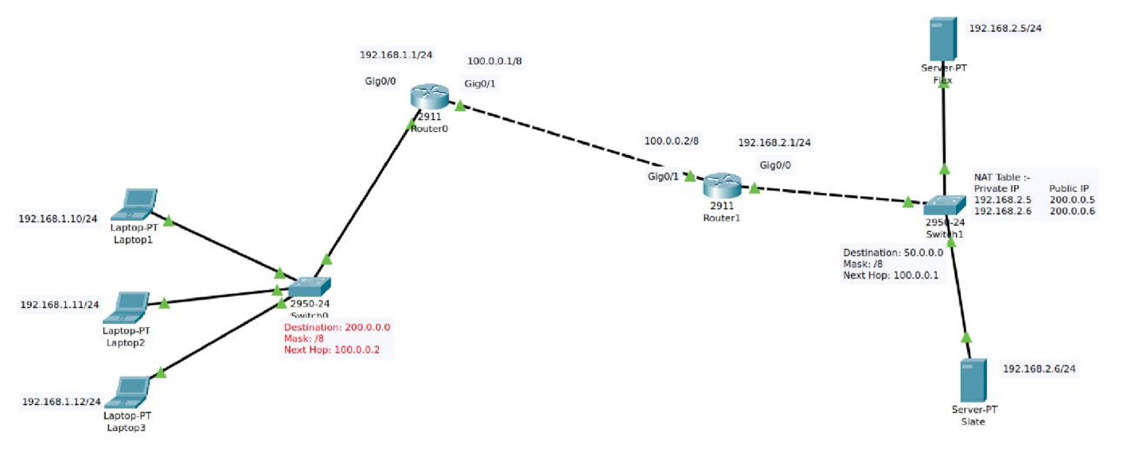

**PC Configuration:**

**Assign Static IP’s to the PC’s**

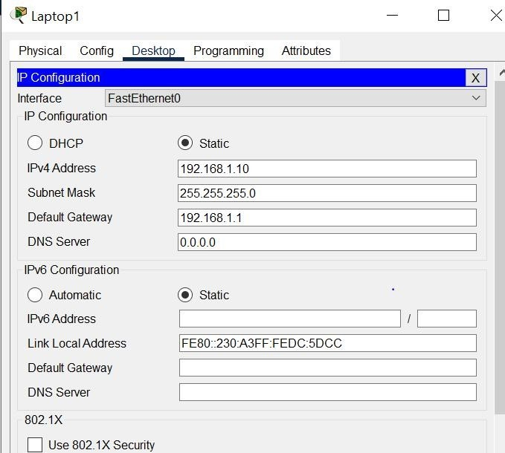

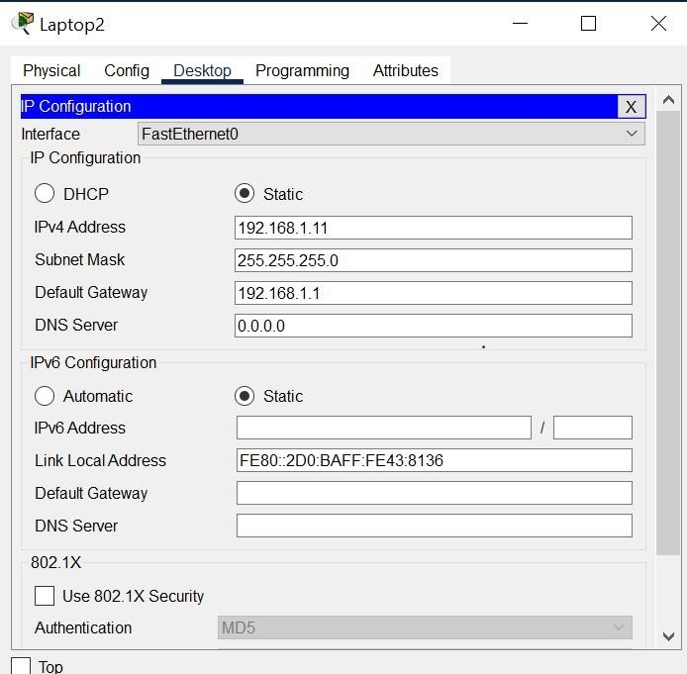

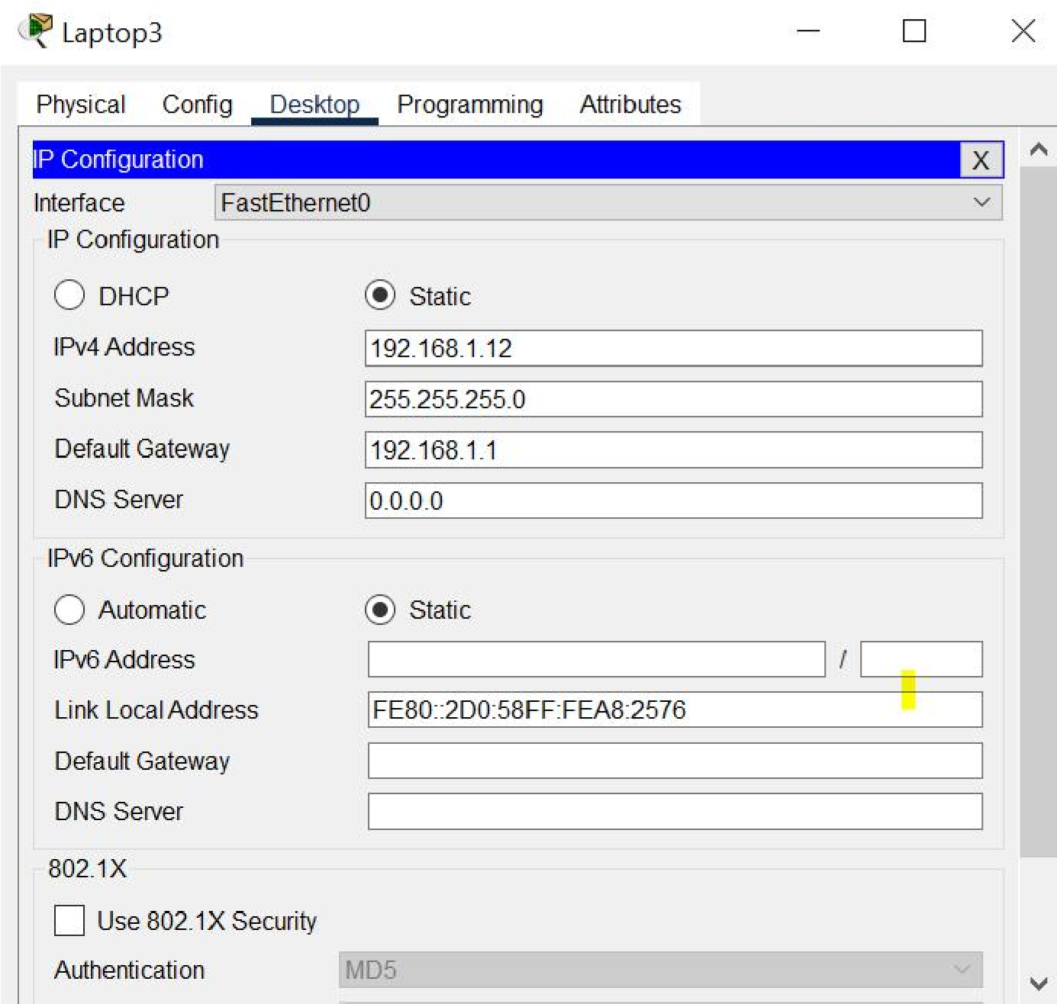

**Server Configuration: Using static IP’s**

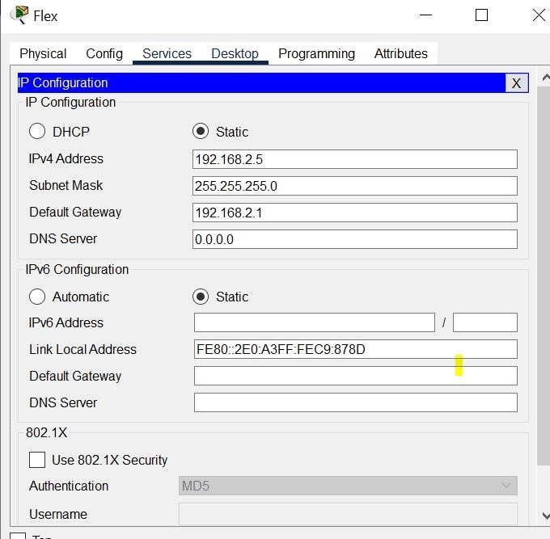

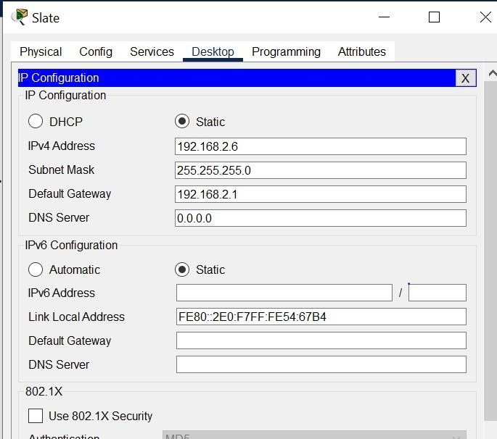

**Router Configuration:**

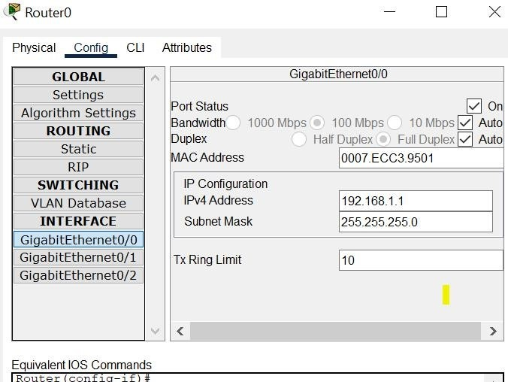

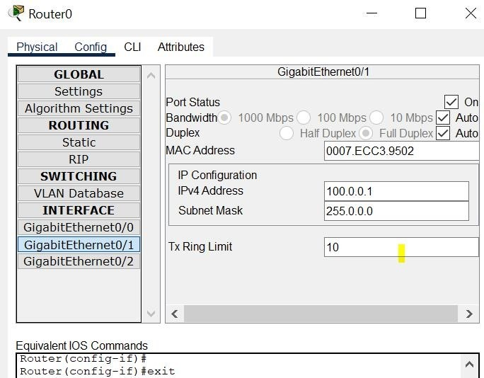

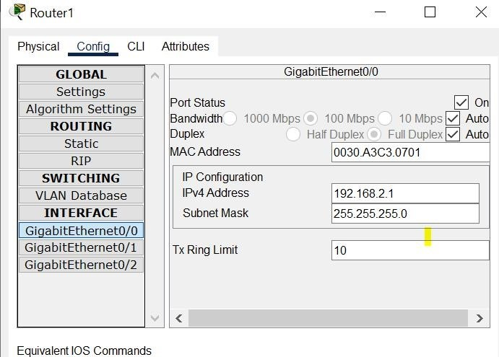

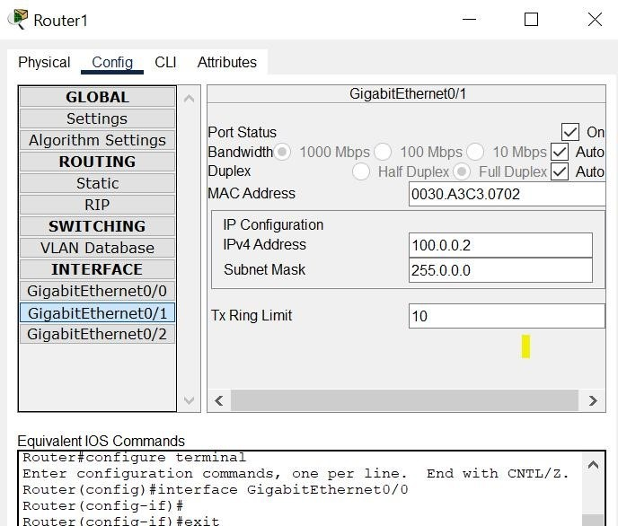

**Configure Dynamic NAT:**

4 STEPS:

1:

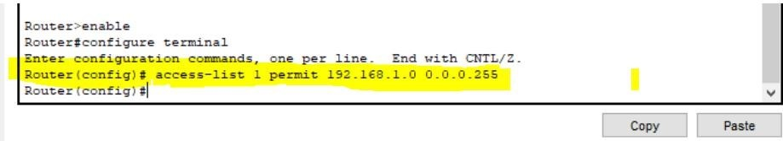

**2:**

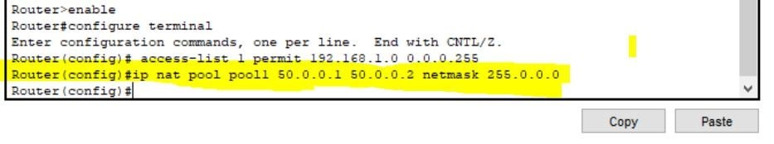

**3:**

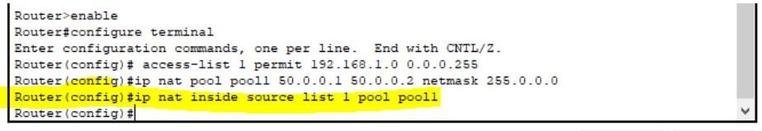

**4:**

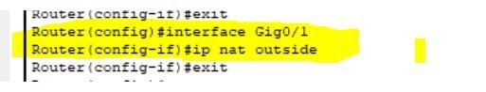

# Testing Dynamic NAT Configuration Using Ping Command:

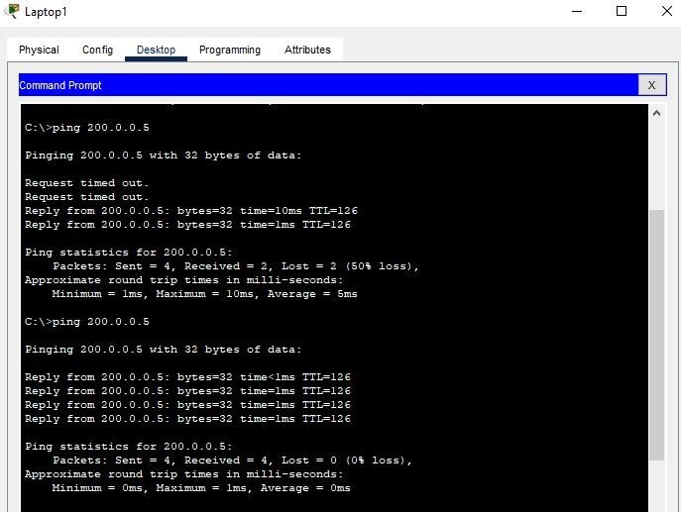

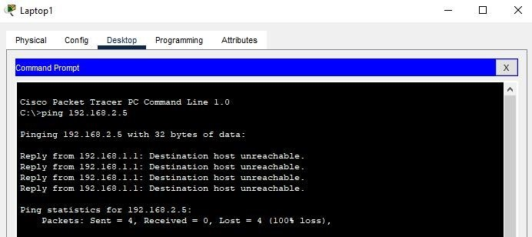

**THEN:**

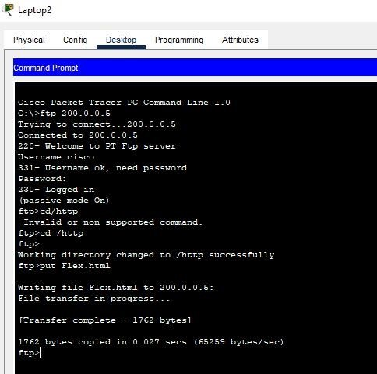

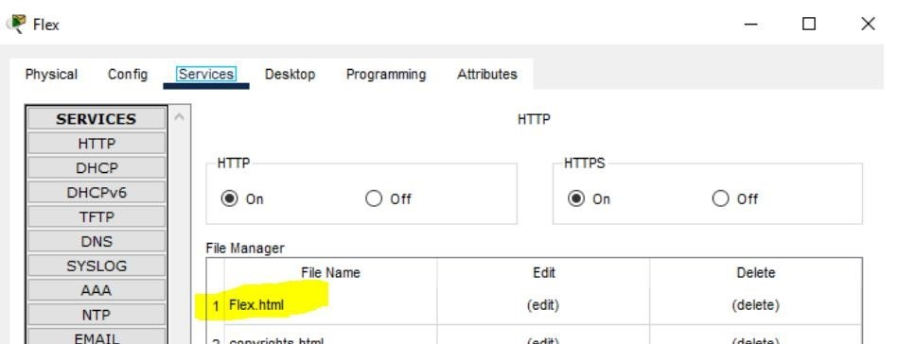

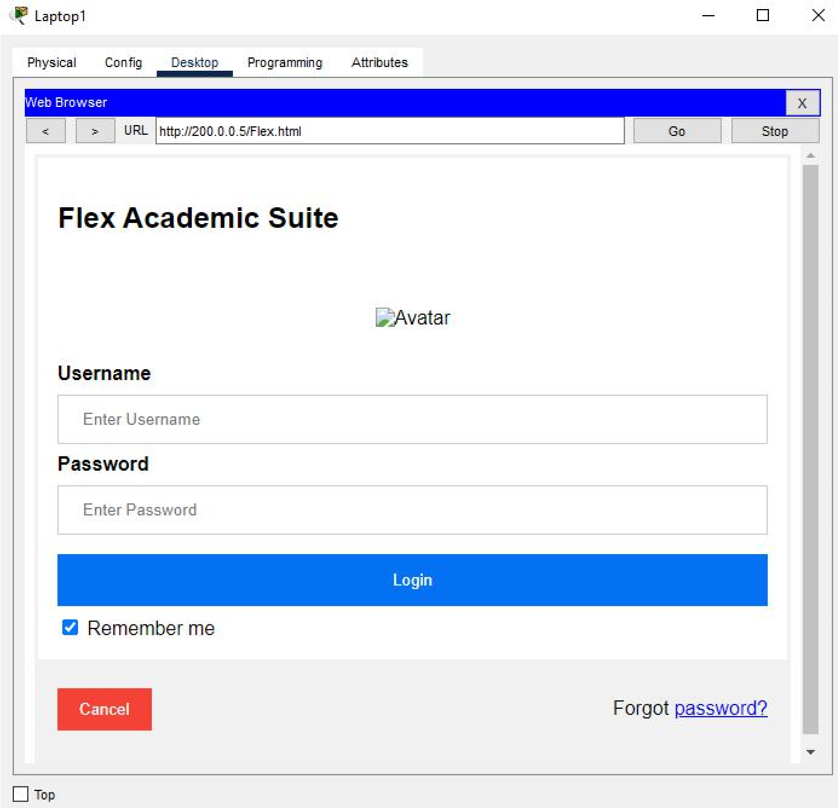

**Done!**